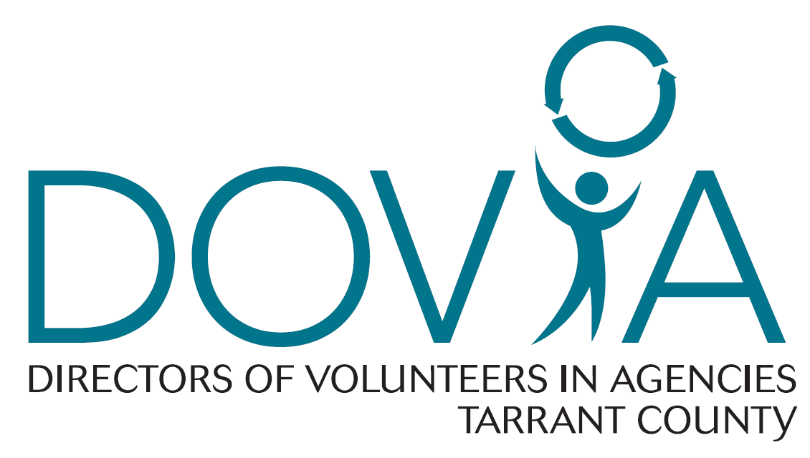
2020 DOVIA Scholarship Application
Must be received 2 weeks prior to conference early registration deadline!
Applicant Name: | Title:
Agency:

Mailing Address:

Phone: | Email:
Conference Title:

Conference Purpose:

Registration Amount: | Full/Partial Amount Requested:
To what extent can your organization financially support this event?

To what extent can you personally financially support this event?

Why do you need a scholarship and how would you benefit from attending this event?

In what way will this conference impact your professional skills?

By signing below, I indicate I understand scholarship funds do not include transportation or other related expenses. I understand that I must register before the early registration deadline and, if I do not, I agree that I am responsible for any additional registration fees. If I am selected, I agree to share with DOVIA materials and information I received from this event by providing a brief summary of information in writing or in person at a DOVIA meeting.
Signature: ___________________________________________ Date: ____________________________
Please return to Jennifer Flynn, 2020 Scholarship Chair, via email, jflynn@mealsonwheels.org

